UNIVERSITY OF LEEDS

Support at Leeds
[Transcriber's note: hyperlinks are given as plain text, and can be pasted into a browser]

[Slide 1]
Support at Leeds
An interactive session with information and activities to help you to:
- find out about your support network
- take care of yourself and your student community
Name:
Job Title:

[Slide 2]
Welcome! Congratulations! How are you feeling?
Activity: Which egg are you?
[Above, a row of six wooden eggs with facial expressions: blue = sad face; yellow = nervously smiling; orange = big smile; green = a little bit puzzled or nervous; purple = feeling unwell or anxious; red = angry.]
- Which expression (eggspression!) matches how you're feeling?
- Introduce yourself to the person next to you and talk about which colour egg you chose and why.
Listen carefully—this session will help you, whichever egg you are feeling like!

[Slide 3]
Introduction to our support for you
[video link]: https://mymedia.leeds.ac.uk/Mediasite/Play/159bdbef87db43048b0542e05657aa081d

[Slide 4]
Our Vision
"To enable and empower you to engage fully with all aspects of student life, removing barriers as necessary, so you can achieve your potential and succeed in your studies"
It’s about …
Maintaining your wellbeing:
' where each individual realises his or her own potential, can cope with the normal stresses of life, can work productively and fruitfully and is able to make a contribution to his or her community' – World Health Organisation
Meeting challenges:
'a task or situation that tests a person's abilities' – Oxford dictionaries https://en.oxforddictionaries.com

[Slide 5]
A wide range of support
- Support to manage student life and develop skills to meet challenges
- Activities to build friendships and maintain your wellbeing and health
- Free specialist confidential support services and independent advice
[photos below: working in the library; Advice in the Students Union; group of walkers in the countryside]
GET OUT. Get active.

[Slide 6]
Online information you can use independently:
- [link]: https://students.leeds.ac.uk
- Faculty/School website/Minerva area
- [link]: luu.org.uk
Contact points for questions and to find out how to get the right support:
- Student Office in School
- Help and Support in Leeds University Union
Specialist support and advice to enable and empower you to meet challenges:
- Personal Tutor (academic support)
- Skills@Library (study skills)
- Advice in Leeds University Union
- Student Counselling and Wellbeing
- Disability Services
- Student Services Centre (including finance)
- International Student Office (immigration)
- Lifelong Learning Centre (mature students)
- Accommodation Wardens and Sub-wardens
- Chaplaincy and Muslim Student Adviser
- University Security & Campus Police Officer

[Slide 7]
Student Counselling and Wellbeing
- Free, confidential, specialist support from an experienced team of counsellors, mental health advisers and wellbeing practitioners
- The team works with students to identify solutions to difficulties and signpost or refer to specialist services in Leeds
- Support includes: wellbeing drop-ins; single session consultations; groups and workshops; online resources; short series of counselling or wellbeing appointments; weekly meditation; downloadable relaxation MP3s on website
- To book an appointment on campus, complete the Student Counselling and Wellbeing Self-Referral Form on [link]: http://students.leeds.ac.uk/supportandwellbeing

[Slide 8]
Disability Services
- Confidential, specialist advice, guidance and support for disabled students, including those with physical disabilities, mental health conditions, autism spectrum condition, specific learning needs (e.g. dyslexia) and long term medical conditions.

- The team identifies and recommends adjustments schools can make for individuals
- Start by filling in Disability Services’ online sign-up form at
[link]: http://students.leeds.ac.uk/settingupyoursupport
- Perhaps you had support or adjustments at school or during previous study? Contact the team at disability@leeds.ac.uk, or look at the website below to see if you might benefit from the team’s services.
- Visit our friendly Disability Services team to find out more. No appointment needed, confidential drop-ins between 9:30am and 4pm Monday to Friday.
[link]: http://students.leeds.ac.uk/disabledstudents

[Slide 9]
Funding and Money Support
Student Funding Team in Student Services Centre
Help and guidance on student funding
Can communicate directly with Student Finance England (and other funding bodies) to help resolve funding issues
Administer applications to Leeds Hardship Fund
and International Leeds Hardship Fund
[link]: https://students.leeds.ac.uk/fundsandscholarships
You can talk to the Student Finance team in Student Services Centre or email funding@leeds.ac.uk
Advice in Leeds University Union
Money help, budgeting advice, financial support
[link]: luu.org.uk/student-help-support
(Photos below – Marjorie and Arnold Ziff building, location of Student Services Centre, and the Leeds University Union foyer, location of Advice in LUU)
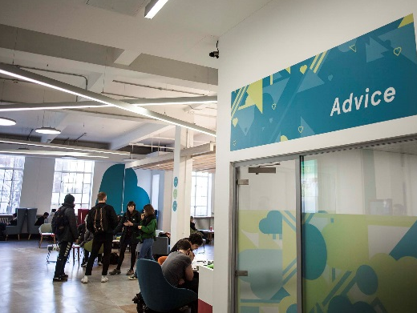

[Slide 10]
Activities for friendship, wellbeing and health
Five Ways to Wellbeing* [link]: https://issuu.com/neweconomicsfoundation/docs/five_ways_to_well-being
- Connect
- Be active
- Take notice (mindfulness)
- Keep learning
- Give
*Five ways to wellbeing report: New Economics Foundation [link]: https://b.3cdn.net/nefoundation/8984c5089d5c2285ee_t4m6bhqq5.pdf
Activity: Your way(s) to wellbeing:
Introduce yourself and share with a partner:
- what you usually do for your wellbeing
- what you could do/would like to do this year
[photo below, Give it a go –
young people talking with an older person]:

[Slide 11]
Our Support Partnership
[triangle diagram below]:
Our Support Partnership:
- Students
- LUU
- University
Students:
- seek information/ advice/support in good time
- contribute positively to your community
- let University/ Leeds University Union (LUU) know about problems or what may need to change
University & Leeds University Union (LUU):
- empower you to manage student life and meet challenges
- work with students to understand what's happening and what's needed
- develop and provide support services and activities

[Slide 12]
Students supporting students, for example:
School-based peer support
School reps (representatives)
Academic societies
Other student-run societies
[link]:luu.org.uk/clubs-and-societies/welfare

- LUU LGBT Society
- Leeds Nightline – 8pm-8am Listening service
- LUU Mantality Society
- LUU Mind Matters Society
- Insulin Army – Active group for people with diabetes. Socials, activism & peer mentoring. Find us on Facebook – Insulin Army

[Slide 13]
Another example ...
A partnership of students, University and Leeds University Union staff developed the "Draw the Line" project to help the University community to stand up to harassment. [link]: https://www.luu.org.uk/student-help-support/hate-crime-reporting-project
Draw the Line: Help us end harassment on campus
Chat to us about your experiences if you've been affected by harassment or hate crime.
Find out how to report incidents and the support available at [link]: luu.org.uk/student-advice
Leeds University Union
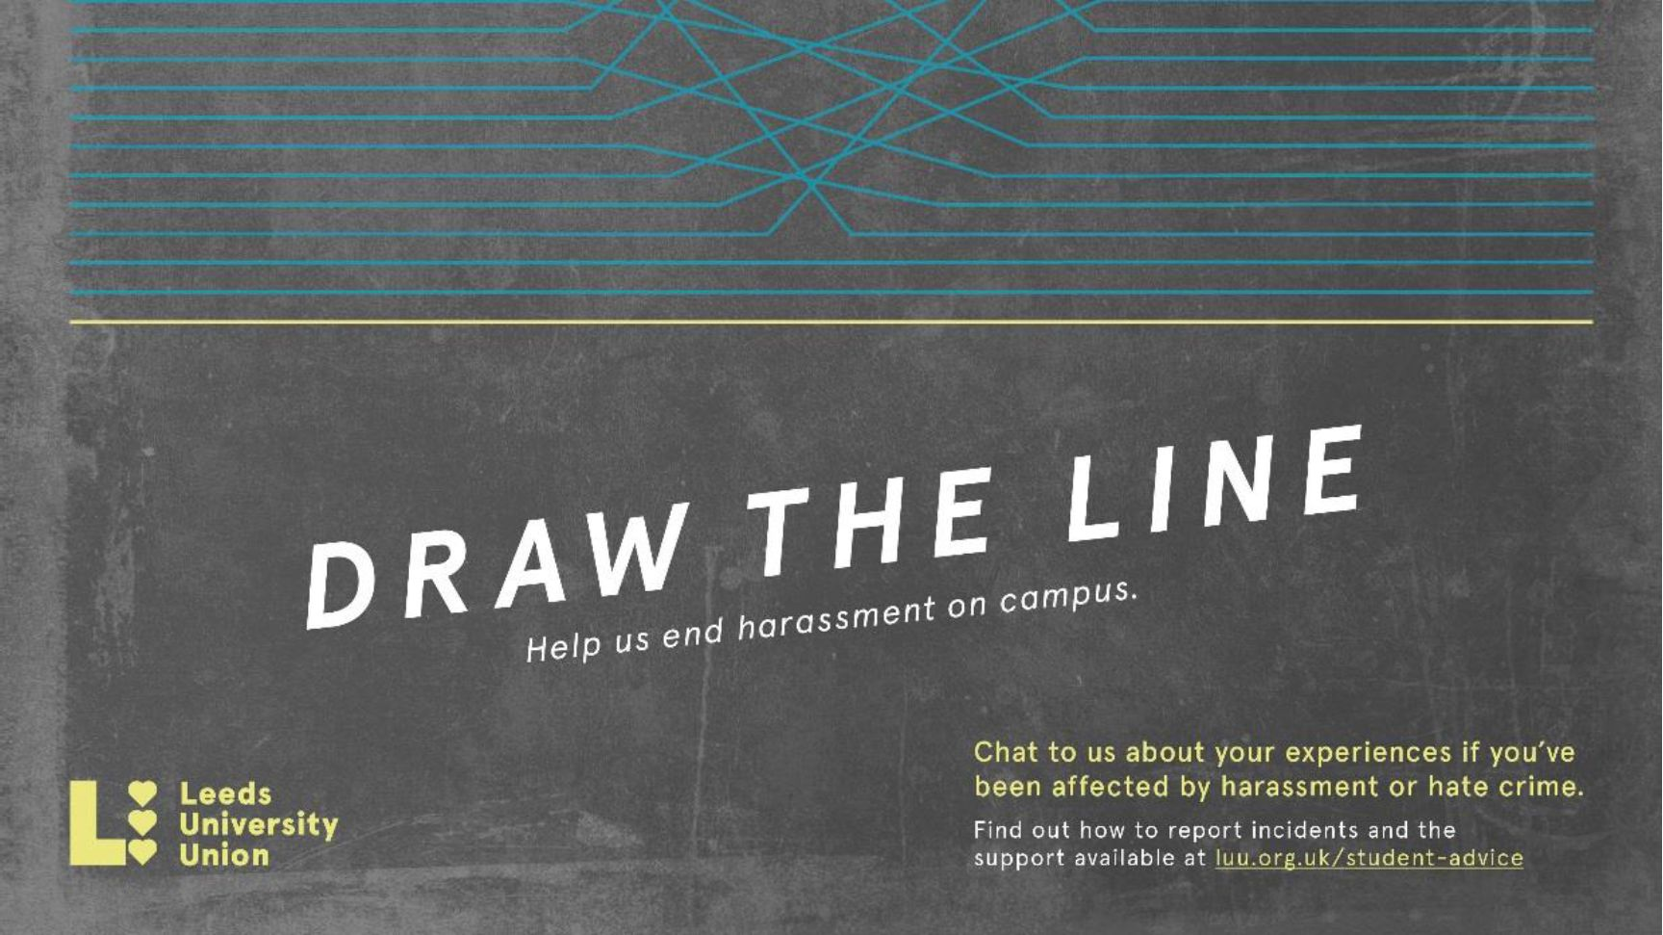
The project raises awareness of the campus online reporting form [link]: luu.org.uk/student-help-support/hate-crime-reporting-project and the support available from LUU Advice [link:] luu.org.uk/student-help-support and our campus police officer PC Becky Hurrell R.Hurrell@leeds.ac.uk
[photos below: PC BECKY HURRELL; PROJECT AMBASSADORS

[Slide 14]
Emergency and outside office hours contact points
University Security Office:
- Open on campus 24 hours, every day of the year
- 175 Woodhouse Lane; email security@leeds.ac.uk
- Tel: 0113 343 5494/5 (non-emergencies); 0113 343 2222 (emergencies)
Ambulance/Police/Fire Emergency phone 999:
- If ambulance is needed on campus, ring University Security first
- Police non-emergency [link]: www.police.uk/contact phone 101
- Nearest Hospital Accident & Emergency [link]: www.leedsth.nhs.uk/a-z-of-services/emergency-medicine is at Leeds General Infirmary
- Wellbeing Crisis information on [link]: https://students.leeds.ac.uk
- Wardens and Sub-wardens in University accommodation

[Slide 15]
Big White Wall—Wellbeing support at any time
24/7 ONLINE & ANONYMOUS SUPPORT FOR MENTAL HEALTH
[image below]
Big White Wall: Get Support, Take Control, Feel Better
Free to all students at the University of Leeds
Knowing Big White Wall is there for me 24/7 gives me peace of mind
[link]:bigwhitewall.com

[Slide 16]
Feeling at Home in Leeds
Online guides to help you settle in and make the most of University life
Explore ideas and strategies to help you:
- Navigate change and cultural differences
- Make friends and maintain your wellbeing
- Find support and discover opportunities
- Thrive in your academic and social life at Leeds
Learn from:
- Videos and interactive activities
- Students’ and researchers’ experiences
- Explore the guides at your own pace
- [link]:http://students.leeds.ac.uk/feelingathome
[Image below]
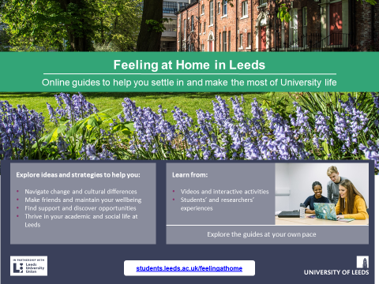

[Slide 17]
Supporting each other
Your friend Alex isn't sure about being able to meet all the academic deadlines this term
- Talk to school Student Support Officer
- Personal tutor for academic support
- Supportive conversation with another student
- Skills@Library study skills workshops, appointments and resources [link]: https://library.leeds.ac.uk/info/1401/academic_skills
- Disability Services support for students affected by a long term condition e.g. dyslexia [link]: http://students.leeds.ac.uk/disabledstudents
- Leeds University Union wellbeing and social activities and workshops [link]: luu.org.uk
- Big White Wall and Feeling at Home in Leeds resources and support [Big White Wall link]: http://students.leeds.ac.uk/info/100002/big_white_wall_resources_and_self_help
[Feeling at Home in Leeds link]: https://students.leeds.ac.uk/feelingathomeonline resources and support
- Student Counselling and Wellbeing Workshops, groups and online resources [link]: http://students.leeds.ac.uk/info/100001/counselling_and_wellbeing
- Get Out Get Active sociable trips and physical activities [link]: https://sport.leeds.ac.uk/sport/get-out-get-active
- Universities Chaplaincy 1 to 1 with a Chaplain [link]: http://unichaplaincy.org.uk
- Leeds Nightline 1 to 1 with a trained student outside office hours [link]: https://leeds.nightline.ac.uk

[Slide 18]
Take away messages ...
Your time at University will test you in different ways, but you'll be empowered to find solutions. You'll develop skills to meet challenges while you're studying and in your future lives.
- Make time for wellbeing (5 ways)—for the best experience and academic results
- Remember the range of support offered by the University, Leeds University Union and other students, including 24/7
- Ask for help as soon as you need it. It's a normal part of University life, a strength not a weakness.
A warm welcome to our supportive University community!
[end]

